Girl Scouts of Southwest Texas and Wellpoint

**Choose Kindness Bullying Prevention Patch**

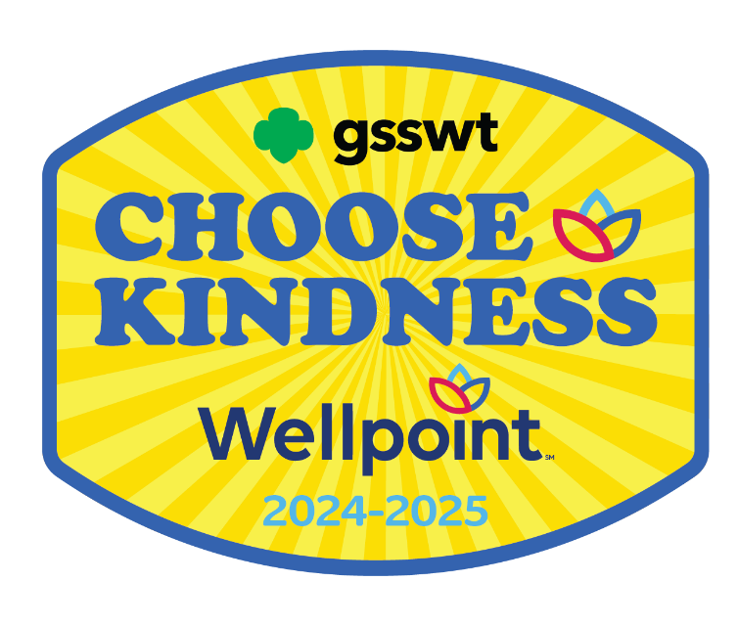

**Girl Scout Brownies**

|  |
| --- |
| Girl Scouts of Southwest Texas  811 North Coker Loop  San Antonio, Texas 78216  (210) 349- 2404 or 1-800-580-7247  [www.girlscouts-swtx.org](http://www.girlscouts-swtx.org/) |



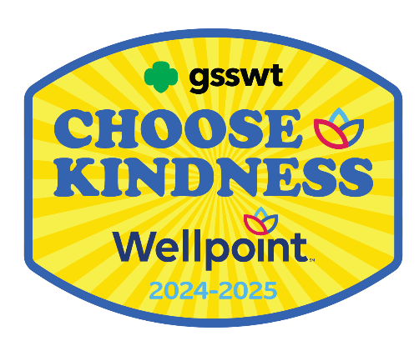

About

Wellpoint, an Elevance Health Company, helps improve health care access and quality for nearly 750,000 Texans who participate in the state’s Medicaid programs.

Wellpoint serves Texans by developing and delivering innovative care management programs and services. Wellpoint members are assured care that is not only accessible, but also accountable, comprehensive, integrated and patient-centered. Wellpoint also provides ongoing community relations and outreach to encourage members to become active participants in their health care.

**Girl Scouts of Southwest Texas & Wellpoint are proud to bring to you the**

**Wellpoint Choose Kindness**

**Bullying Prevention Patch**

The purpose of the Wellpoint Choose Kindness Bullying Prevention Patch is to provide girls the tools and resources to maintain health and overall well-being in their lives.

Steps to Earn the Wellpoint

Choose Kindness Bullying Prevention Patch

Girl Scouts is the premier girl leadership development program—girls have fun with a purpose! All activities are girl-led, and girls should decide what activities to complete when earning a Patch Partner Initiative (PPI) patch. In the spirit of Girl Scouting, girls may choose to participate in activities that are not listed in the booklets and/or supplements.

If girls complete the minimum required number of activities based on the theme of the PPI, they have earned the PPI patch.

Step One:

1. Read through the Activities
2. Think about what you would like to do
3. Choose 3 out of the 4 Units
4. Complete 2 Activities from each unit you chose (total of 6 activities)

Step Two:

1. Email our Customer Care team at [customercare@girlscouts-swtx.org](mailto:customercare@girlscouts-swtx.org) with the following information:
   * Your name and role.
   * Name and Girl Scout Grade Level of each girl who completed the requirements to earn the patch.
2. Mailing address to receive the patches.

Step Three:

1. Receive your Wellpoint Patch!

The Girl Scout Leadership Experience

Girls at every level of Girl Scouting participate in *“leadership experience.”* A *leadership experience* is an exciting way of working with girls in a series of themed activities focused on building leadership skills. By enlisting the three keys to leadership (*Discover, Connect,* and *Take Action*) girls learn that they can take the lead to make a difference in their community and the world. The three keys are at the heart of the Girl Scout philosophy of leadership:

Discover

Girls understand themselves and their values and use their knowledge and skills to explore the world.

Connect

Girls care about, inspire, and team with others locally and globally.

Take Action

Girls act to make the world a better place.

It’s not just “what” girls do, but “how.” When girls are engaged that creates a high- quality Girl Scout leadership experience. All Girl Scout experiences are built on three processes (*Girl-Led*, *Cooperative Learning*, and *Learning by Doing*) that make Girl Scouting different from school and other extra-curricular activities. When used together, these processes ensure the quality and promote the fun and friendship so integral to Girl Scouting.

Girl-Led

Girls play an active role in the planning and implementation of activities while adults provide age-appropriate facilitation, ensuring that planning, organization, set-up, and evaluation of all activities are done jointly with the girls.

Cooperative Learning

All members of a group work together towards a common goal that can only be accomplished with the help of others.

Learn by Doing

A “hands-on” learning process that engages girls in cycles of action and reflection resulting in deeper understanding of concepts and mastery of practical skills.

When Discover, Connect, and Take Action activities are girl-led and involve learning by doing and cooperative learning, girls achieve the desired and expected leadership outcomes ultimately resulting in Girl Scouting achieving its mission: **Building girls of courage, confidence and character, who make the world a better place.**

*This page intentionally left blank.*

|  |  |  |
| --- | --- | --- |
| TABLE OF CONTENTS | | |
| UNIT | ACTIVITY | PAGE |
|  |  |  |
| Feelings | Paint a Mood | 9 |
|  | I AM ME | 10 |
|  | What About Jealousy? | 11 |
| Empathy | Empathy In Action | 13 |
|  | Kindness Week | 14 |
|  | Everyone is Included on a Team | 15 |
| Bullying | Anti-Bully Message | 18 |
|  | Positive Words | 19 |
|  | Be An Upstander | 20 |
| Cyberbullying | Girl Scout Internet Pledge | 22 |
|  | What is a Cyber Bully? | 23 |
|  | Cyber Etiquette | 24 |

FEELINGS

Paint a Mood

Feelings are important. Often, they let us know if we are safe or in danger. We need to know what our feelings are telling us. In this activity, we will use the feeling chart. We may even learn a word for a feeling we have had.

Materials: Number of materials depends on the desires and number of girls participating.

* Poster Paper (one for each girl)
* Paint brushes (at least one for each girl)
* Paint (variety of colors)
* Cup for water (to rinse of brushes

The definition of mood is “a state of mind or feeling.” Our emotions create our mood.

Discuss the feelings chart with your adult leader and each other.

Part of Legacy Artist is Painting a Mood. Explore using color to describe your mood and emotion today. It is important to know our emotions because they give us clues about what is going on in our lives. Share your painting with your fellow Brownies and family.

I AM ME

You are uniquely beautiful. There is no one like you on the planet. Even if you are an identical twin, you have differences. Celebrate YOU. Do you sometimes feel sad, lonely, or hurt? Maybe you don’t feel like you can do things as well as everyone else. Everyone feels like this at some point in their life.

If you ever feel sad, lonely, or hurt for a long time, tell your parents, scout leader, teacher, or an adult you trust. They can help you figure out what to do to help you feel better.

For this activity, we are going to remind ourselves about what is wonderful about ourselves! Sometimes it is hard to think of things, so help each other to come up with one thing.

1. What is one thing you are good at?

2. What is one thing you want to learn?

3. Can you teach someone how to do something?

Teach a friend or a fellow Girl Scout something you know how to do.

Some ideas:

* a dance step
* hand stand
* how to braid your hair
* the words to a song

You all know something you can teach.

When we learn new things, it makes us feel good. When we teach someone something, we learn to be patient. It feels good to share your talents.

If you want to do something more: Work on “My Best Self” Badge.

## What About Jealousy?

We all feel many different emotions. Sometimes we are happy, excited, nervous, afraid, and mad. Jealousy is a complicated emotion. It is very powerful. Jealousy doesn’t feel good.

Can we do something when we feel jealous of someone? Maybe your friend won a prize or received a compliment and you got jealous of them.

Pick one of the things below and try them.

* Practice giving compliments when someone does something good.
* Make a list of all the things I have, to remind me how lucky I am.
* Recite the Girl Scout Law:

*I will do my best to be*

*honest and fair,*

*friendly and helpful,*

*considerate and caring,*

*courageous and strong,*

*and responsible for what I say and do,*

*and to respect myself and others,*

*respect authority,*

*use resources wisely, make the world a better place,*

*and be a* sister to every Girl Scout.

For Girls Who Want to Do More:

Materials: Number of materials depends on the desires and number of girls participating.

* Laptop/Tablet/Desktop
* Internet access.

Watch Jealousy in our lives, cartoon 3:06 minutes

<https://www.youtube.com/watch?v=YvJvyD4yaWc>

Talk about what was happening in the video.

EMPATHY

Empathy in Action

The definition of empathy, understanding and sharing the feelings of another person. We meet all kinds of people, but we don’t really know what they are going through. In this activity you will work on your philanthropist badge.

For this activity, focus on Philanthropist Badge, Step 2, Investigate How to Help People who are Hungry. With your Girl Scout troop or your family, research three organizations that provide food to people.

## One organization in your community you can research is the San Antonio Food Bank. <https://safoodbank.org>

## They help feed individuals and families. They even help feed pets!

Brainstorm how you could help one of the organizations get food to people.

## For Girls Who Want to Do More:

Research and plan a field trip to visit or volunteer at one of the organizations you researched.

## San Antonio Food Bank Volunteer Opportunities

<https://safoodbank.org/ways-to-help/give-time-opportunities/>



Kindness Week

You never know if someone is having a hard day or if they got some bad news. Maybe they are being bullied and feel alone.

Think about how you can help make their week better. Talk with your fellow Girl Scouts or your family about when you have seen someone do an act of kindness. Talk with your troop what is something you can do to be kind to someone. Plan one act of kindness for each day of the week.

## For Girls Who Want to Do More:

## Materials: Number of materials depends on the desires and number of girls participating.

* 1 sheet of the week chart (below) for each girl
* Glue sticks
* Scissors
* Pens, Markers, Crayon

# Watch Abbey D'Agostino and Nikki Hamblin's Act of Kindness

# <https://www.facebook.com/olympics/videos/712511860044042/> 2:11 minutes

Print out the week calendar. You can decorate it. Decide what act of kindness you can do. You can do some on your own and some with your Girl Scout troop.

|  |  |
| --- | --- |
| Monday |  |
| Tuesday |  |
| Wednesday |  |
| Thursday |  |
| Friday |  |
| Saturday |  |
| Sunday |  |

As part of Fair Play in your Brownie book, look up Abbey D'Agostino or Nikki Hamblin’s (or both!) as your Professional Woman in Sports.

Everyone is Included on a Team

Bullies don’t play fair. Bullies like to have their own way and they like it when people are hurt, embarrassed or fail. Girl Scouts want everyone to be successful. Imagine what it would be like to be different from everyone.

Play the Blindfold game.

## Materials: Number of materials depends on the desires and number of girls participating.

* 1 Strip of Fabric (to blindfold one person)
* Paper
* Pens/markers/ pencil

One girl is seated at a table with paper and a marker or pencil in front of them. They are blindfolded. Then another girl asks them to draw a picture. Keep it simple. It can be a house or building or a tree or flower.

Take turns trying to draw blindfolded. Discuss how it felt to draw without being able to see.

For Girls Who Want to Do More: In the Fair Play read about Step 2- Include Everyone. Choose Learn about Disabilities and Sports.

Watch Scarlett <https://www.youtube.com/watch?v=JOWiPx5VRUU> 2:49 minutes

Additional Activities:

Go on a field trip to Morgan’s Wonderland and learn about how to include everyone in the game.

BULLYING

Anti-Bully Message

### Bullying is when you pick on someone because you think you’re cooler, smarter, stronger, or better than they are. It is simple. If you call someone names, threaten to hurt someone, or actually hurt someone, steal things from them, embarrass them and make fun of them, you are a bully.

Discuss with your Girl Scout troop or family, how we can stop bullies. Read the Girl Scout Law. It says a Girl Scout is considerate and caring, plus courageous, and strong.

If a Girl Scout follows the Girl Scout Law, they cannot be a bully.

*I will do my best to be*

*honest and fair,*

*friendly and helpful,*

*considerate and caring,*

*courageous and strong,*

*and responsible for what I say and do,*

*and to respect myself and others,*

*respect authority,*

*use resources wisely, make the world a better place,*

*and be a sister to every Girl Scout.*

Think of ways to get the message out to stop bullying.

For Girls Who Want to Do More:

## Materials: Number of materials depends on the desires and number of girls participating.

* Butcher paper and scotch tape
* Glue sticks
* Scissors
* Pens, Markers, Crayon
* Paint/Paintbrushes
* Bowls for water
* Rulers
* Stencils for letters and shapes

For this activity, you will look at Step 5, Legacy Artist Paint A Mural. Either by yourself or with your Girl Scout troop, design a mural to draw to show an anti-bully message. You can make it as large as you like by taping sheets of butcher paper together! After you design it, paint the mural!

After you finish the mural find a place to display it. You can see if you can display it at your school, public library, church, or community center. Display it at a Girl Scout camp event.

Positive Words

Bullies like when people are afraid of them. Girl Scouts want to make the world better for everyone. Look at the Brownie Leadership Awards. It’s Your Story – Tell It A World of Girls. Better World for Girls.

Do you think stopping bullies might make it a Better World for Girls?

You may be thinking “What can I do?”

One way to help stop bullying is to help people who are bullied is to let them know someone cares. We don’t always know who is being bullied. It can happen at school or the neighborhood and even online. Think of ways you can let people know that you care.

For Girls That Want to Do More:

## Materials: Number of materials depends on the desires and number of girls participating.

* Card stock or colored construction paper.
* Pens and markers
* Stickers, magazines, glitter, glue. You can use your imagination.

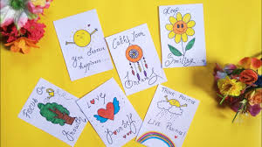For this activity, we will make Positive Message Cards to give to people. You can do this as a project with your Girl Scout troop or family. You make and decorate cards using paper and add messages on the cards. You can make them for specific people that you know can use some encouragement or write some you can give to people in the moment.

You can find messages and quotes on the internet to use.

# If you need some ideas, watch DIY

# Cute motivation card ideas | card tutorial <https://www.youtube.com/watch?v=lKiEF3Pfbm0> 8:12 minutes

# Be an Upstander

Bullies use fear. They can be mean because everyone is afraid of them. One way we make things worse is by watching someone being bullied and we laugh. We might laugh because we don’t want to get bullied or we ignore what is going on. An upstander is someone who sees everything and does something to try and help make it better.

For this activity, read or ask your Girl Scout troop leader to read the following story.

*There is a student in school who seems shy and seems somewhat different. They are having a hard time making friends, but most students seem to ignore them. A few students make cruel comments and snicker when they walk by. They walk to class alone, eat by themself in the cafeteria, and often sit alone on the school bus.*

Some suggestions for being an Upstander:

# Reach out to new students at school and help them feel comfortable.

# Don’t encourage the person who is bullying.

# Do not join in, laugh, or stand guard for them.

# Tell the person who is bullying to stop.

# You can also say something such as, “That isn’t funny.

Talk about some other things you can do to be an Upstander.

For more information:

# Be an Upstander - Prevent Bullying: A NED Short 4 minutes <https://www.youtube.com/watch?v=eeqQCyQOCPg&t=1s>

For Girls Who Want to Do More:

You can write your own story and script, or you can use the story and write a script. Act it out and then using some of the suggestions from the video, role play different ways to be an upstander.

This can help you know what to do if you see it happening in your school or anywhere else.

Girl Scout Safety Internet Pledge

# The internet is full of information, games, and education. Do you want to learn a new language? Learn how to do a math problem? Play a new game? Do you want to learn how to fix or even build a car? You can find the information all on the internet. There are also many bad people that want to hurt you.

For this activity, we will discuss and sign the Girl Scout Safety Pledge. There are 12 things that are very important guidelines for using the internet. If you have already signed this pledge, you can still review it. Talk about why it is important to follow the Internet Pledge.

# For Girls That Want to Do More:

## Materials: Number of materials depends on the desires and number of girls participating.

* A copy of the Girl Scout Internet Safety Pledge from the Brownie book for each girl.
* Tablet/Laptop or desktop with speakers

Materials for the For Girls Who Want to Do More:

* Markers
* paints, stickers, glitter
* Colored paper

# Watch Second and Third Grade Internet Safety <https://www.youtube.com/watch?v=pzdSaGtavEI>

7:13 minutes

Discuss with your parents or adult Girl Scout leader each of the 12 guidelines and why they are important to follow.

For Girls Who Want to Do More:

Make a paper frame for your signed pledge and hang it in your bedroom or somewhere everyone in your family can see it, so everyone can be safe.

CYBERBULLYING

What is Cyber Bullying?

It is fun getting online and posting pictures and sharing videos. It is a good way to keep in touch with your friends. Memes are funny. When does having fun become bullying?

Using the scenarios below talk about it with your parents, scout leaders and friends.

Decide what should be done.

1. A boy brought his cell phone to school one day and used the phone to take pictures of other students in school. The next day the teacher sees that some of the students are threatening to beat up the boy. The teacher finds out that the pictures were posted on the Web with funny captions under each. What punishment should the boy get? Should the other students be punished for threatening him?
2. Two girls at school are teasing each other during lunch time. They are calling each other names and laughing at one another. Both girls are punished, and the teacher thinks that the fighting has stopped. Rather than fight at school the students have started an online fight. One girl created an entire Web page to make fun of the other. The girl who is on the Web site has told her parents. Now the parents have come to the teacher asking why and what is going on. What should the teacher recommend to the parents? What should the teacher do while the students are at school?

Here are some questions to think about.

* Is it bullying or being mean?
* What should the teacher, school, students, and parents do?

Cyber Etiquette

The internet is a wonderful place to learn all kinds of things. Just like when your parents taught you how to act when you go to someone’s house, there are rules for behaving online. It is important to know the rules for keeping the internet safe for everyone.

For this activity, you will discuss Cyber Etiquette with your Brownie leader and fellow Brownies or your parents. This might be a good activity as a Girl Scout camp activity.

If you follow these rules, you will help keep others safer and help prevent bullying.

As a brownie Girl Scout, you promise as part of the Girl Scout promise” To help people at all times.” By following the rules, you will be helping other people to stay safe.

1. Never attack others online. Don’t say anything online that hurts someone’s feelings, attacks one’s character, or invades one’s privacy online or offline.
2. Don’t pose as someone else and post under someone else’s name.
3. Don’t write, post, or send anything when you are angry. Cool down and then re-read the message.
4. Don’t reply to anything that insults you. This may be hard but, usually, the bully quickly becomes bored and stops if they don’t get a reaction.
5. If you receive hateful or threatening emails or texts, you must tell your parents or teachers immediately.
6. Don’t open strange emails that may be offensive. Delete without responding.
7. Don’t’ go to unknown web sites.
8. Don’t answer texts from unknown numbers.
9. If you know someone who is being bullied online, tell an adult you trust.
10. Everyone has a right to use email, their cell phone, or a social networking site without being harassed, insulted, hurt, or embarrassed.
11. Don’t try to stop cyber-bullying with more cyber-bullying. Delete without responding – Ignore to beat cyber-bullies!

Cyberbullying is against the law. Cyber bullies are breaking the law.

The name of the law is David’s Law. Learn more by following this link: <https://www.davidslegacy.org/programs/legislation/>

**You did it!**



**Congratulations!**

**End of Booklet**

|  |
| --- |
| Girl Scouts of Southwest Texas  811 North Coker Loop  San Antonio, Texas 78216  (210) 349- 2404 or 1-800-580-7247  [www.girlscouts-swtx.org](http://www.girlscouts-swtx.org/) |