Girl Scouts of Southwest Texas and Wellpoint
Choose Kindness Bullying Prevention Patch

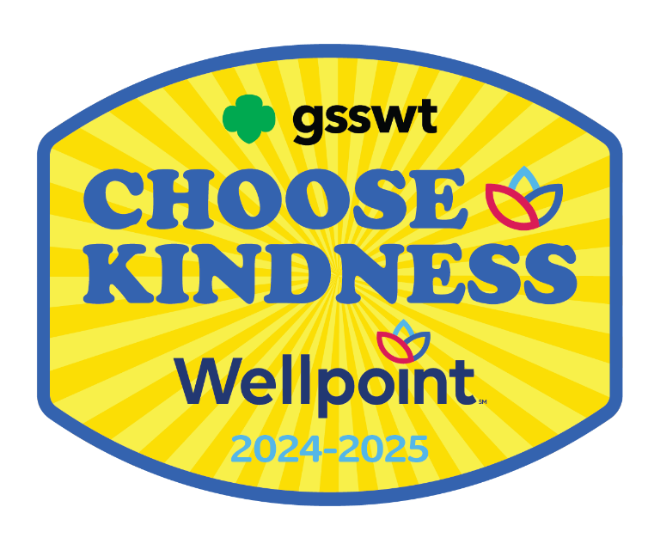

Girl Scout Cadettes

Girl Scouts of Southwest Texas
811 North Coker Loop
San Antonio, Texas 78216
(210) 349- 2404 or 1-800-580-7247
www.girlscouts-swtx.org


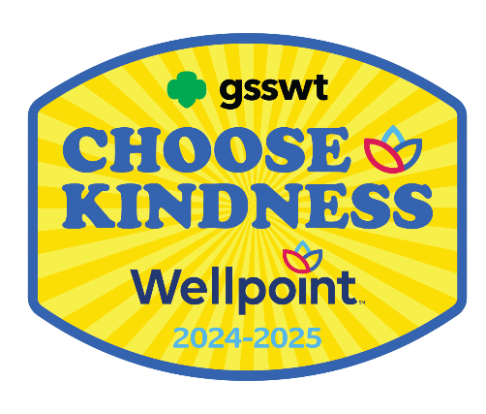

About

Wellpoint, an Elevance Health Company, helps improve health care access and quality for nearly 750,000 Texans who participate in the state’s Medicaid programs.

Wellpoint serves Texans by developing and delivering innovative care management programs and services. Wellpoint members are assured care that is not only accessible, but also accountable, comprehensive, integrated and patient-centered. Wellpoint also provides ongoing community relations and outreach to encourage members to become active participants in their health care.

Girl Scouts of Southwest Texas and
Wellpoint are proud to bring to you the
Wellpoint Choose Kindness
Bullying Prevention Patch

The purpose of the Wellpoint Choose Kindness Bullying Prevention Patch is to provide girls the tools and resources to maintain health and overall well-being in their lives.
Steps to Earn the Wellpoint
Choose Kindness Bullying Prevention Patch

Girl Scouts is the premier girl leadership development program—girls have fun with a purpose! All activities are girl-led, and girls should decide what activities to complete when earning a Patch Partner Initiative (PPI) patch. In the spirit of Girl Scouting, girls may choose to participate in activities that are not listed in the booklets and/or supplements.

If girls complete the minimum required number of activities based on the theme of the PPI, they have earned the PPI patch.

Step One:
- Read through the Activities
- Think about what you would like to do
- Choose 3 out of the 4 Units
- Complete 2 Activities from each unit you chose (total of 6 activities)

Step Two:
- Email our Customer Care team at customercare@girlscouts-swtx.org with the following information:
  - Your name and role.
  - Name and Girl Scout Grade Level of each girl who completed the requirements to earn the patch.
- Mailing address to receive the patches.

Step Three:
- Receive your Wellpoint Patch!

The Girl Scout Leadership Experience

Girls at every level of Girl Scouting participate in “leadership experience.” A leadership experience is an exciting way of working with girls in a series of themed activities focused on building leadership skills. By enlisting the three keys to leadership (Discover, Connect, and Take Action) girls learn that they can take the lead to make a difference in their community and the world. The three keys are at the heart of the Girl Scout philosophy of leadership:

Discover
Girls understand themselves and their values and use their knowledge and skills to explore the world.

Connect
Girls care about, inspire, and team with others locally and globally.

Take Action
Girls act to make the world a better place.

It’s not just “what” girls do, but “how.” When girls are engaged that creates a high- quality Girl Scout leadership experience. All Girl Scout experiences are built on three processes (Girl-Led, Cooperative Learning, and Learning by Doing) that make Girl Scouting different from school and other extra-curricular activities. When used together, these processes ensure the quality and promote the fun and friendship so integral to Girl Scouting.

Girl-Led
Girls play an active role in the planning and implementation of activities while adults provide age-appropriate facilitation, ensuring that planning, organization, set-up, and evaluation of all activities are done jointly with the girls.

Cooperative Learning
All members of a group work together towards a common goal that can only be accomplished with the help of others.

Learn by Doing
A “hands-on” learning process that engages girls in cycles of action and reflection resulting in deeper understanding of concepts and mastery of practical skills.

When Discover, Connect, and Take Action activities are girl-led and involve learning by doing and cooperative learning, girls achieve the desired and expected leadership outcomes ultimately resulting in Girl Scouting achieving its mission: Building girls of courage, confidence and character, who make the world a better place.

This page intentionally left blank.

TABLE OF CONTENTS
UNIT |  | ACTIVITY | PAGE
 | Feelings | What Am I Feeling? | 9
 |  | Gratitude Exercise | 10
 |  | Art and Emotions | 12
 | Empathy | Learn To Care | 14
 |  | Actions Are Louder Than Words | 15
 |  | Understanding Girls Around the World | 16
 | Bullying | Are You Okay? | 18
 |  | I Can Be An Upstander | 19
 |  | Documentarian – Making a Difference | 20
 | Cyberbullying | Making the World A Safer Place | 22
 |  | Cyber Safety | 23
 |  | Daniels’ Law | 25

FEELINGS

What Am I Feeling?

The definition of mood is “a state of mind or feeling.” Our emotions create our mood and affects how we act and treat others. Think about the times you have been sad, angry, annoyed. It is normal to feel this way some of the time. Sometimes, we wake up annoyed or in a bad mood, maybe we didn’t get enough sleep or are hungry. Just because we FEEL a certain way does not mean we can treat other people rudely.


For this activity, First think about how you FEEL. How does your body feel? Second think about how you ACT when you feel a certain emotion.

You can make a collage. You can write about it. You have to be honest with yourself. When you are angry or annoyed do you yell or say unkind things? If you are sad, do you avoid people? Think about what you DO when you feel a certain emotion.

The Third part is to make a plan for a better way to behave. Just because we FEEL a certain way, does not excuse bad behavior.
If you plan how you will act no matter how you feel, you may find you feel better and you can get rid of the negative emotion.

Materials: Number of materials depends on the desires and number of girls participating.
- Paper
- Glue sticks
- Scissors
- Pens, Markers, Crayons
- Pictures (from magazine, catalogs…)
Gratitude Exercise

You have so many emotions. Sometimes you get angry, sad, annoyed or lonely. You also get excited, happy, or thankful. Being angry, annoyed, sad or lonely isn’t very enjoyable. However, feeling this way sometimes is very normal. We don’t want to make it a habit. Our emotions affect our moods and negative emotions can affect our health. We can sleep, feel sick or can’t eat.

You have the power to have more positive emotions each and every day.

For this activity, you will practice gratitude. A definition of gratitude is focusing on what's good in our lives and being thankful for the things we have.
You can work on the Cadet Science of Happiness Badge while doing these activities.

For this activity, practice gratitude: There are three parts: (1) Noticing, (2) Savoring and (3) Expressing Gratitude.

Noticing Gratitude in Your Life Complete one of these activities
- Each day for seven days think of 2 things you are grateful for. It might be your house, your parents, grandparents, friends, a good meal, or good weather.
- Keep a gratitude journal for 7 days. Writing down good things each day makes it more likely that we will notice good things as they happen.
- Practice gratitude rituals for 7 days. Take a moment before you eat dinner to feel gratitude for the food that you are eating. Repeat a saying or quote every morning as you get ready for your day. Some suggestions:
  - When we give cheerfully and accept gratefully, everyone is blessed.”
- Maya Angelou
  - “Don’t pray when it rains if you don’t pray when the sun shines.”
- Leroy Satchel Paige
  - “Gratitude opens the door to the power, the wisdom, the creativity of the universe. You open the door through gratitude.”
– Deepak Chopra

  - “What separates privilege from entitlement is gratitude.”
– Brené Brown

Savoring Gratitude - Take a moment. If you would like to, draw a picture or write it down.
There are moments when you naturally, right then and there, feel filled with gratitude. These are moments when you say to yourself, "Oh, wow, this is amazing!" or "How great is this!"
Pause. Notice and absorb that feeling of true, genuine gratitude. Let it sink in. Soak it up. Savor your blessings in the moment they happen.

Express Gratitude-Do two of the activities below.
- Show your appreciation to someone who did something nice. Say: "It was really kind of you to…," "It really helped me out when you…," "You did me a big favor when…," "Thank you for listening when…," "I really appreciated it when you taught me…," or "Thank you for being there when…." You also can write your gratitude in a letter.
- Express gratitude by doing a kindness. Gratitude might inspire you to return a favor, or act with kindness or thoughtfulness. Or you might see a situation when you can "pay it forward." Hold the door open for the person behind you, even if it means waiting a little longer than you normally would. Do someone else's chores without letting the person find out it was you. Notice how you feel afterward!
- Tell the people in your life how you feel, what they mean to you. You don't have to be mushy or over-the-top. We all have our own style. But if you say what you feel in the right tone at the right moment, even a simple, "Mom, good dinner. Thanks!" means a lot.
- Gratitude is a gift you can give to yourself and others, not expecting anything in return.


Art and Emotion

We feel so many emotions! How would you describe each of the emotions? What would Happy look like? Anger? Jealousy? Loneliness? Joy? Excitement?

For this activity, you can also work on the Comic Artist Badge.

Materials: Number of materials depends on the desires and number of girls participating.

- Paper
- Hole punch
- Yarn or string
- Glue sticks
- Scissors
- Pens, Markers, Crayons. Colored pencils
- Pictures (from magazine, catalogs…)

Create a comic book of emotions. You can use the picture below to give you inspiration. You can make it silly or serious. Create a graphic novel around one or more emotions.
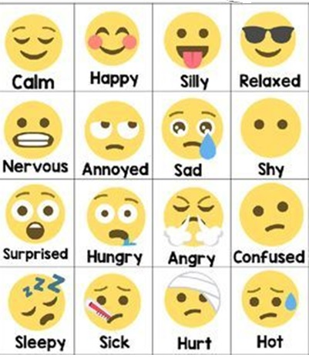

EMPATHY

Learn to Care

Empathy is the ability to understand and share a person’s feelings. If you’re an empathetic person, you can listen to what someone else has to say without judgment. You can learn and practice empathy in your community.

For this activity, we will focus on bullying. Do you know people in your school or community that are bullied? You might have felt sorry for them because you can imagine it would be awful and you would not want it to happen to you. Bullied people feel alone. Many people feel alone.

Materials: Number of materials depends on the desires and number of girls participating.

Suggested Materials:
- Cardstock
- Paint
- Markers
- Brushes
- Computer/phone/tablet (to watch video or create a message)

Watch the video “Under the Surface” https://www.youtube.com/watch?v=AZ-pU7ozt3g 3 minutes 55 seconds.
This video is good to watch with your troop, friends, or family.

After you watch the video, think about some of the situations.
- Imagine what it would be like to experience one of the situations.
- Think about the adults in the video, what do you think it is like for them?
- Think about someone you know that you don’t like. Is there a reason or do you not really know them?
- After watching the video, Pick one person that you have judged or may have misunderstood. Create a positive message for them. Create a card and leave it on their desk, locker, drop it off or mail it to them. You can even create a message using software like Publisher or Word.

Actions Are Louder Than Word

Sympathy and Empathy are not the same thing.

Sympathy is when we feel bad about something. “I am sorry your grandmother died.” We mean what we say, but we don’t have to do anything. We may not even want to talk about it.

Empathy is trying to understand how the person is feeling. We are willing to listen. We are willing to do something for the person even when it is inconvenient. Compassion takes it a step further. We need empathy to be able to be compassionate.

Watch this video “Compassion in Action.”
https://www.youtube.com/watch?v=4bozIrVVVok 5 minutes 5 seconds

After you watch the video, think about what the man said to the little girl.

Think of how you can make a compassionate act. Just one act of kindness.
It can be a small one-time act, like the man in the video.

For girls that want to do more:
Do step 1 in the Finding Common Ground- Legacy Citizen

Choose to get to know someone different than you. It can be a neighbor or someone at school. The more we learn about each other, the more we find we want most of the same things!

Understanding Girls Around the World


Girls around the world may live very differently from you. Using the Screen Writer Badge, research some differences and write a script for a movie.

Understanding can lead to empathy. By researching your screen play, you will learn a lot about the day-to-day activities of girls all over the world.


After you write the script, consider making a short film about the problems that girls around the world face. This might be a great troop or camp activity. You can have Daisies and Brownies help you with the project.
You can teach them about girls around the world.

Here are some short videos to watch that show some differences between the United States and other parts of the world.

First world problems read by third world people 1 minute 13 seconds
https://www.youtube.com/watch?v=LDLqafWub_o

First World vs Third World Problems 2 minutes 47 seconds
https://www.youtube.com/watch?v=Uy5hnI9qweg

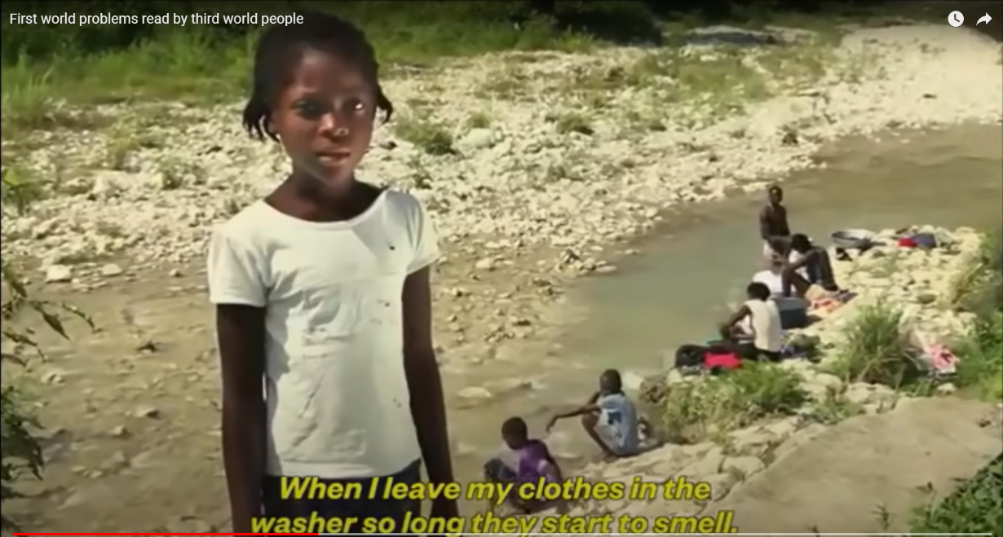

BULLYING

Are You Okay?

Bullying happens around the world in all countries. Bullying is harmful behavior.
Students ages 12-18 experienced various types of bullying, including:
- Being the subject of rumors or lies (13.4%)
- Being made fun of, called names, or insulted (13.0%)
- Pushed, shoved, tripped, or spit on (5.3%)
- Leaving out/exclusion (5.2%)
- Threatened with harm (3.9%)
- Others tried to make them do things they did not want to do (1.9%)
- Property was destroyed on purpose (1.4%)

For this activity, all you need is access to a computer, tablet or phone, and access to the internet.

You can do this activity as part of your troop, as a camp activity or with your family. You can use this activity as part of bridging to Girl Scout Senior, Step 1, Pass it On.

Watch the video are you okay? | Award-Winning Short Film - YouTube

Discussion Questions:
- What happened to the boy?
- What did the girl do?
- What happened when she tried to help?
- Do you think she made a difference?

For those that want to do more:
Look up StopBullying.gov and learn about bullying, and how you can prevent it.



I Can Be an Upstander

Bullies use fear. They can be mean because everyone is afraid of them. One way we make things worse is by watching someone being bullied and we laugh. We might laugh because we don’t want to get bullied or we ignore what is going on. An upstander is someone who sees bullying and does something to try and help make it better. This activity has many choices for you to do.

What Makes the Highest Performing Teams in the World | Simon Sinek
https://www.youtube.com/watch?v=zP9jpxitfb4 1 minute 21 seconds

As you learn about bullying you may wonder what you can do. There are many things:
- Be kind to someone who is being bullied.
- Don’t ignore them.
- Don’t be part of the bullying by laughing or encouraging the bully.
- Report to your troop what you did and how it felt.
- Were you afraid to be an upstander? It can be hard.

Use bullying prevention as a project for your silver award. Bullying is an issue faced by girls around the world.

These links have some information about bullying. Report what you learn to your troop.
- Bullying, Violence Common in Schools Worldwide. https://www.hrw.org/news/2020/11/05/bullying-violence-common-schools-worldwide

School violence and bullying a major global issue, new UNESCO publication finds https://www.unesco.org/en/articles/school-violence-and-bullying-major-global-issue-new-unesco-publication-finds

Bullying: a global challenge requires a global measure https://www.unicef-irc.org/article/1867-bullying-a-global-challenge-requires-a-global-measure.html

For girls who want to do more or as part of their silver award:

Start an anti-bullying club in your school.

Read about how to start one: NATIONAL ASSOCIATION OF PEOPLE AGAINST BULLYING https://www.napab.org/antibullying-services/school-antibullying-clubs
- Organize World Bullying Prevention Month activities in October. https://www.stompoutbullying.org/world-bullying-prevention-month#:~:text=October%20is%20National%20Bullying%20Prevention,which%20is%20observed%20throughout%20October
Documentarian – Making a Difference

Bullying is a worldwide issue. As part of the digital moviemaking badge, make a video about bullying.

Research what bullying is.
David’s Legacy Foundation. https://www.davidslegacy.org/programs/legislation/
Stomp Out Bullying https://www.stompoutbullying.org/?gclid=CjwKCAiA_6yfBhBNEiwAkmXy587fRCYD35Z36BN2GDyBeQloUNc6oTIni2hY7buaiPETLNayHsHAnRoC-LUQAvD_BwE

You can use your video to educate people about the effects of bullying and why it is a problem. You could document people’s experiences with bullying with interviews. You can ask your family and friends to be in your video.

Here is free software to edit your videos to add music, a title and credits at the end. Videopad Video Editor https://www.nchsoftware.com/videopad/index.html

After you edit your video, share it in your troop meeting, at a camp or at your school during Bully Prevention month. You may decide to upload your video to iTunes, and Youtube so you can educate more people.

How to add movies to iTunes. https://www.softwarehow.com/add-movies-to-itunes/



CYBERBULLYING

Making the World a Safer Place

Cyber bullying is a huge problem. Cyber-bullying is committed by people you know but can be done by strangers.
You can work on your Public Speaker badge while accomplishing this activity.

The first step is to research the definition and statistics about cyber bullying.

Stop Bullying https://www.stopbullying.gov/cyberbullying/what-is-itFrequency of Cyberbullying

Pacer’s National Bullying Prevention Center. https://www.pacer.org/bullying/info/stats.asp

There are two sources of federally collected data on youth bullying:
- The 2019 School Crime Supplement to the National Crime Victimization Survey (National Center for Education Statistics and Bureau of Justice) indicates that, nationwide, about 16 percent of students in grades 9–12 experienced cyberbullying.
- The 2019 Youth Risk Behavior Surveillance System (Centers for Disease Control and Prevention) indicates that an estimated 15.7% of high school students were electronically bullied in the 12 months prior to the survey.

The second part is to prepare and present a speech about any aspect of cyber bullying. You can explain the statistics and impact. You can have a call to action to some change in behavior. You may want to convince people to participate in a campaign. You can do it at school, church, a troop meeting or a Girl Scout camp.

You decide.

For those that want to do more:
Create a campaign to stop all forms of bullying. At the David’s Legacy Foundation there is a complete free tool kit on how to do a campaign at your school or community. This would be an excellent project for the Silver award.
Be The Change Student Empowerment https://www.davidslegacy.org/programs/education/be-the-change-student-empowerment/

Cyber Safety

As you know the internet is a great resource for learning and fun, However, it can also be a place where people say harmful things. We all need to be aware of what information we put on the internet and what we say on the internet.
You should be able to use this activity to work on your Netiquette Badge.

The first thing to do is review the Girl Scout Internet Safety Pledge* for All Girl Scouts.
- I will not give out personal information such as my address, telephone number(s), parent's or guardians' work address/telephone number(s), and the name and location of my school without the permission of my parent or guardian.
- I will tell an adult right away if I come across or receive any information that makes me feel uncomfortable.
- I will always follow the rules of Internet sites, including those rules that are based on age of use, parental approval and knowledge, and public laws.
- I will never agree to get together with someone I "meet" online without first checking with my parents or guardians. If my parents or guardian agree to a meeting, I will arrange it in a public place and bring a parent or guardian along.
- I will never send a person my picture or anything else without first checking with my parent or guardian.
- I will talk with my parent or guardian so that we can set up rules for going online. We will decide on the time of day that I can be online, the length of time that I can be online, and appropriate areas for me to visit. I will not access other areas or break these rules without their permission.
- I will follow all of the Girl Scout Terms and Conditions related to Digital Cookie, as well as all internet safety guidelines related to all other Girl Scout product sales.
- I will practice online etiquette (good manners) at all times when online by:
- Not spamming others.
- Not bullying or tolerating bullying (and will always tell a trusted adult if this is a problem).
- Not using bad language.

- I will be guided by the Girl Scout Promise and Law in all that I do online.

For this activity, all you need is access to a computer, tablet or phone, and access to the internet.

You can do this activity by yourself or with your Girl Scout troop, class or friends, research netiquette and decide on 7 rules for good behavior for internet communication. After you do your research, you can brainstorm which are the top 7 (you can have more!) that everyone should follow.

Here are some web sites to get ideas:
https://online.louisiana.edu/blog/10-tips-ensure-youre-using-good-netiquette
https://www.mccc.edu/~virtcoll/Netiquette.pdf
https://www.utep.edu/extendeduniversity/utepconnect/blog/october-2017/10-rules-of-netiquette-for-students.html
https://www.verywellmind.com/ten-rules-of-netiquette-22285

Create a document with your 7 or more rules for positive online behavior. Share it with others.

For those that want to do more:
Create a social media post with your rules of online positive online behavior. You can ask for suggestion on what to add.

Cyber Bullying and Daniel’s Law

- Never attack others online. Don’t say anything online that hurts someone’s feelings, attacks one’s character, or invades one’s privacy online or offline.
- Don’t pose as someone else and post under someone else’s name.
- Don’t write, post or send anything when you are angry. Cool down and then re-read the message.
- Don’t reply to anything that insults you. This may be hard but, usually, the bully quickly becomes bored and stops if they do not get a reaction.
- If you receive hateful or threatening emails or texts, you must tell your parents or teachers immediately.
- Don’t open strange emails that may be offensive. Delete without responding.
- Don’t’ go to unknown web sites.
- Don’t answer texts from unknown numbers.
- If you know someone who is being bullied online tell an adult you trust
- Everyone has a right to use email, their cell phone or a social networking site without being harassed, insulted, hurt or embarrassed.
- Don’t try to stop cyber-bullying with more cyber-bullying. Delete without responding – Ignore to beat cyber-bullies!

Cyberbullying is against the law. Cyber bullies are breaking the law.
The name of the law is David’s Law https://www.davidslegacy.org/programs/legislation/

For this activity, as part of bridging to Girl Scout Senior, educate younger Girl Scouts about cyber bullying, both to prevent them for being a cyberbully and to protect themselves from being bullied online.

You can do this activity at a camp or as a troop meeting activity.

Create a skit, role play or do an art activity to help younger girls understand how to protect themselves and to prevent others from being a target.
You can use the web site below from David’s Legacy Foundation as a guide for an action that girls can take.
I PLEDGE TO NEVER USE MY DEVICE AS A WEAPON” https://www.davidslegacy.org/programs/education/sticker-pledge-and-posters/
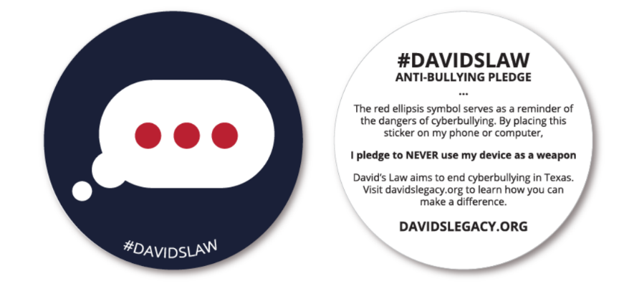

You did it!

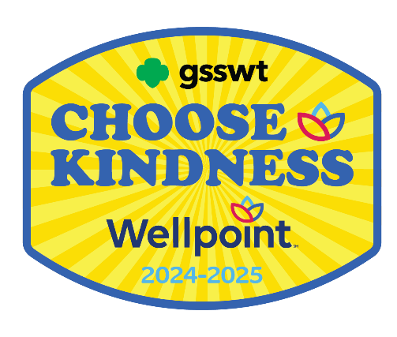

Congratulations!

End of Booklet

Girl Scouts of Southwest Texas
811 North Coker Loop San Antonio, Texas 78216
(210) 349- 2404 or 1-800-580-7247
www.girlscouts-swtx.org

