Girl Scouts of Southwest Texas and Wellpoint

**Choose Kindness Bullying Prevention Patch**

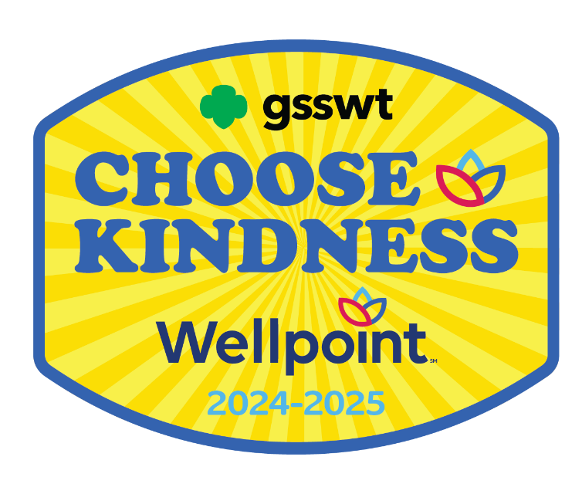

**Girl Scout Juniors**

|  |
| --- |
| Girl Scouts of Southwest Texas  811 North Coker Loop  San Antonio, Texas 78216  (210) 349- 2404 or 1-800-580-7247  [www.girlscouts-swtx.org](http://www.girlscouts-swtx.org/) |



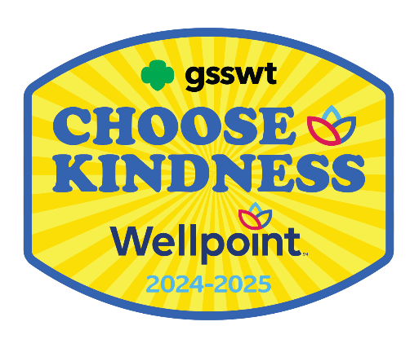

About

Wellpoint, an Elevance Health Company, helps improve health care access and quality for nearly 750,000 Texans who participate in the state’s Medicaid programs.

Wellpoint serves Texans by developing and delivering innovative care management programs and services. Wellpoint members are assured care that is not only accessible, but also accountable, comprehensive, integrated and patient-centered. Wellpoint also provides ongoing community relations and outreach to encourage members to become active participants in their health care.

**Girl Scouts of Southwest Texas and**

**Wellpoint are proud to bring to you the**

**Wellpoint Choose Kindness**

**Bullying Prevention Patch**

The purpose of the Wellpoint Pully Prevention Patch is to provide girls the tools and resources to maintain health and overall well-being in their lives.

Steps to Earn the Wellpoint

Choose Kindness Bullying Prevention Patch

Girl Scouts is the premier girl leadership development program—girls have fun with a purpose! All activities are girl-led, and girls should decide what activities to complete when earning a Patch Partner Initiative (PPI) patch. In the spirit of Girl Scouting, girls who may choose to participate in activities that are not listed in the booklets and/or supplements.

If girls complete the minimum required number of activities based on the theme of the PPI, they have earned the PPI patch.

Step One:

1. Read through the Activities
2. Think about what you would like to do
3. Choose 3 out of the 4 Units
4. Complete 2 Activities from each unit you chose (total of 6 activities)

Step Two:

1. Email our Customer Care team at [customercare@girlscouts-swtx.org](mailto:customercare@girlscouts-swtx.org) with the following information:
   * Your name and role.
   * Name and Girl Scout Grade Level of each girl who completed the requirements to earn the patch.
2. Mailing address to receive the patches.

Step Three:

1. Receive your Wellpoint Patch!

The Girl Scout Leadership Experience

Girls at every level of Girl Scouting participate in *“leadership experience.”* A *leadership experience* is an exciting way of working with girls in a series of themed activities focused on building leadership skills. By enlisting the three keys to leadership (*Discover, Connect,* and *Take Action*) girls learn that they can take the lead to make a difference in their community and the world. The three keys are at the heart of the Girl Scout philosophy of leadership:

Discover

Girls understand themselves and their values and use their knowledge and skills to explore the world.

Connect

Girls care about, inspire, and team with others locally and globally.

Take Action

Girls act to make the world a better place.

It’s not just “what” girls do, but “how.” When girls are engaged that creates a high- quality Girl Scout leadership experience. All Girl Scout experiences are built on three processes (*Girl-Led*, *Cooperative Learning*, and *Learning by Doing*) that make Girl Scouting different from school and other extra-curricular activities. When used together, these processes ensure the quality and promote the fun and friendship so integral to Girl Scouting.

Girl-Led

Girls play an active role in the planning and implementation of activities while adults provide age-appropriate facilitation, ensuring that planning, organization, set-up, and evaluation of all activities are done jointly with the girls.

Cooperative Learning

All members of a group work together towards a common goal that can only be accomplished with the help of others.

Learn by Doing

A “hands-on” learning process that engages girls in cycles of action and reflection resulting in deeper understanding of concepts and mastery of practical skills.

When Discover, Connect, and Take Action activities are girl-led and involve learning by doing and cooperative learning, girls achieve the desired and expected leadership outcomes ultimately resulting in Girl Scouting achieving its mission: **Building girls of courage, confidence and character, who make the world a better place.**

*This page intentionally left blank.*

|  |  |  |
| --- | --- | --- |
| **TABLE OF CONTENTS** | | |
| UNIT | ACTIVITY | PAGE |
|  |  |  |
| Feelings | Learning to Recognize Your Feelings | 9 |
|  | Who Am I? | 10 |
|  | Visualize Yourself | 11 |
| Empathy | Exploring Empathy | 13 |
|  | Kindness in Action | 14 |
|  | Empathy in Action the Girl Scout Way | 15 |
| Bullying | Anti-Bully Photo Booth | 18 |
|  | Teaching Peace Through Words | 19 |
|  | Stop Bullying Theater | 20 |
| Cyberbullying | Learning What to Do About Cyber-Bullying | 22 |
|  | Stand Up to Cyber Bullies | 23 |
|  | Rules for Cyber Surfing | 24 |

FEELINGS

Learning to Recognize Your Feelings

The definition of mood is “a state of mind or feeling.” Our emotions create our mood. Our feelings can confuse us. Look at the chart below and think about a time you felt the emotion.

What were you doing or what was happening when you felt calm or annoyed? Talk about it in your troop.

For Girls That Want To Do More:

Part of the Staying Fit Badge is about lessening your stress. Negative emotions like sadness, anger, frustration can cause us to feel sick and uncomfortable.

For this activity, write in a journal for a week or longer, how you feel each day. You can do it on a computer or in a notebook. You can decorate the page with pictures instead of words. Think about when and why you felt the emotion. Writing down your feelings is a good way to lessen the stress and figure out what you can do about it.

Who Am I?

As a Junior Girl Scout, you are learning about leadership in your community and in the world. After learning the Scout Law and Promise, you started to explore the Three Keys of Leadership. One of the keys is learning about yourself and what is important to you. As a Girl Scout, you promise to be fair and considerate, to help others and to make the world a better place.

For this activity, we will use one of the three keys of leadership: Discover.

Think about the following questions: Discuss it with other Girl Scouts, troop leader or parents.

1. What is one thing you are good at?

2. What is one thing you want to learn?

3. Can you teach someone how to do something?

When we learn new things, it makes us feel good. When we teach someone something, we learn to be patient. It feels good to share your talents.

Visualize Yourself

Our emotions affects our behavior. If we feel sad, it might be hard to get stuff done or want to try new things. If we are angry, we might be mean to people we care about. Being calm and satisfied makes it easier to do things we want to do.

For this activity, we will each create a vision board. It is a way to think about your dreams. Having goals and dreams on a vision board will help you remember your goals especially when you get sad, angry, or jealous.

Your vision board is unique to you. Even if you share similar goals with other people, how you accomplish them and some of the steps will be different. Don’t think about what someone else will do. A vision board is unique to every person who makes one.

You can do it on a computer or on poster board.

Materials: Number of materials depends on the desires and number of girls participating.

* 1 poster board for each girl
* Glue sticks
* Scissors
* Pens, Markers, Crayon, paint
* Pictures from old magazines, brochures, newspapers, or printed off the internet.

# If you want more help about how to make a vision Watch the video - How To Make A Vision Board | 2021 SIMPLE 5:40

<https://www.youtube.com/watch?v=YcntJImMNNA>

There are more videos on the internet about vision boards.

EMPATHY

Exploring Empathy

Empathy is often confused with sympathy, but they are not the same thing. Sympathy is a feeling of concern for someone. You can feel sympathy for someone you see in tears in the street, for example, without knowing anything about their situation. You really don’t know if they are crying because they are happy or sad.

As Girl Scouts, you work to learn empathy. You recite the Girl Scout Promise and Law. When you look at the words, it tells you how you can have empathy for others.

**The Girl Scout Promise**

On my Honor, I will try:

To serve GOD and my country,

To help people at all times,

And to live by the Girl Scout Law.

**Girl Scout Law**

I will do my best to be  
honest and fair,  
friendly and helpful,  
considerate and caring,  
courageous and strong,  
and responsible for what I say and do,  
and to respect myself and others,  
respect authority,  
use resources wisely,  
make the world a better place,  
and be a sister to every Girl Scout.

Talk about how the Girl Scout Promise and Law remind us about empathy.

For Girls That Want To Do More:

## This activity is best done as a group, either at a Girl Scout camp or with the troop.

## Materials: Number of materials depends on the desires and number of girls participating.

* Floor Space
* Paper or paint tape

Put a line of tape in the middle of the group, with girls facing each side’s line. Read a series of statements. If the statement is true for the student, they go stand on the line.

This could include statements like “I’ve lost a family member,” “I’ve been bullied at school,” My parents are divorced”. “I am the oldest in my family” “I am an only child” “I have lived in the same house my whole life.” Some of the statements can be about feelings. Have each girl write one if they want to and put it in a pile, so no one knows who wrote which one. You will find out you have many things in common.

Kindness In Action

## When we feel empathy, we can see the world from another person’s perspective. An example is when your family member or friend has something good happen to them and you are happy for them and not jealous.

The best way to learn to be kind is to do kind things for people. It is like any other skill, we get better at it when we practice.

At your troop meeting, talk about ways you can be kind to people. You can think about a specific person or things you can do for anyone.

How will you make a difference?

If you are able, watch at least one of the videos listed below:

# The Science of Kindness <https://www.youtube.com/watch?v=O9UByLyOjBM> 2:15 minutes

# Color Your World With Kindness <https://www.youtube.com/watch?v=mdA2sByFX1I> 2:13 minutes

Discuss the videos with your junior scouts or your family. What did they do to be kind? What happened when they were kind?

For Girls That Want to Do More:

## Materials: Number of materials depends on the desires and number of girls participating.

* Print a month calendar for each girl.
* Glue sticks
* Scissors
* Pens, Markers, Crayon
* Computer, Tablet, or phone (to watch videos)

Use the month calendar and think of what act of kindness you can do in a month. Write them down.



Empathy in Action the Girl Scout Way

Girl Scouts want to make the world a better place for all. Empathy is not sympathy. It is not feeling sorry for someone. It is being able to relate to how someone is feeling.

This activity is best done with your family or scout troop. Research an organization that helps people in your community. Find out what they do and if you can do a volunteer activity for the organization.

## Some suggested organizations that always need volunteers:

## A picture containing logo Description automatically generatedRaul Jimenez Thanksgiving Dinner. <https://www.rauljimenezdinner.com/>

## “During the holiday season, many senior citizens are alone and cannot afford to prepare a holiday meal for themselves. In 1979, San Antonio restaurant owner and businessman, Raul Jimenez, recognized this need in his community and established a Thanksgiving Day event designed to serve these forgotten individuals.”

Many Girl Scout troops help serve on Thanksgiving Day and they make decorations for the celebration before Thanksgiving Day. There are many opportunities to help.

San Antonio Food Bank <https://safoodbank.org/>

The San Antonio Food Bank takes pride in fighting hunger, feeding hope in our 29-county service area. We believe that no child should go to bed hungry, adults should not have to choose between a hot meal and utilities, nor a senior sacrifice medical care for the sake of a meal.

Girl Scouts can help sort food for customers while learning about food needs.

San Antonio Humane Society <https://sahumane.org/>

**The San Antonio Humane Society mission is to protect and improve the lives of dogs and cats by providing shelter, care, adoption, rescue, spay/neuter programs, and community education.**

BULLYING

Anti-Bully Photo Booth

### Bullying is when you pick on someone because you think you’re cooler, smarter, stronger, or better than they are. It is simple. If you call someone names, threaten to hurt someone, or actually hurt someone, steal things from them, embarrass them and make fun of them, you are a bully.

Discuss with your Girl Scout troop or family, how we can stop bullies. Read the Girl Scout Law. It says a Girl Scout is considerate and caring, plus courageous, and strong. If a Girl Scout follows the Girl Scout Law, they cannot be a bully.

I will do my best to be

honest and fair,

friendly and helpful,

considerate and caring,

courageous and strong,

and responsible for what I say and do,

and to respect myself and others,

respect authority,

use resources wisely, make the world a better place,

and be a sister to every Girl Scout.

## Materials: Number of materials depends on the desires and number of girls participating.

* Poster board for signs
* Markers, Paint, Glue, Stickers (anything you want to you use to make signs for the photo booth.

For this activity, you will look at Digital Photographer. You can accomplish Step 2, and 4 with this activity. You can do this activity on your own or with others. Make anti- bullying signs for people or make the signs as part of a troop activity. After you make the signs, ask people to pose with them and take their picture. Make a collage of all the pictures and share them to help raise awareness about bullying.

If you need some help deciding on some good slogans or messages for your signs, below is a list of web sites with many suggestions!

<https://helpfulprofessor.com/anti-bullying-slogans>

<https://foodtruckempire.com/news/anti-bullying-campaign-slogans/> (this site has quotes, slogans, and memes

<https://sloganshub.org/anti-bullying-slogans/>

Teaching Peace Through Words

Girl Scouts want to make the world better for everyone. Words are compelling. Words can change people’s minds. All around us people create stories to help us understand each other. Other people research a problem and write newspaper or magazine articles to educate the world.

In this activity, all you need is access to a computer, access to the internet and computer paper if you want to print.

Go to <https://wordart.com/create> On this website you can create word art. Word Art can be a powerful message. There are many different colors, fonts, and shapes.

Below is an example of how it looks. Make one about bullying and then one positive message. Do you see what a strong message it can be?

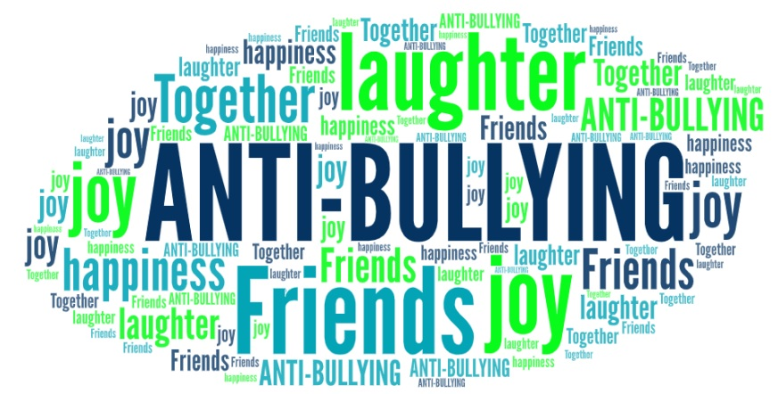

Share your word art.

For Girls that want to do More: Do this as a camp activity and then create an art gallery for everyone to show their word art.

# Stop Bullying Theater

Bullies can’t bully unless people let them. If you see someone being bullied and you ignore it or you join in the bullying, you are helping the bully.

Plays and movies are powerful ways to educate people. For this activity, you can do a skit with your Girl Scout troop or ask your teacher or your church. This would be a great activity at a Girl Scout camp.

Below is a script. You can use this one the way it is. You can change it or use this one as inspiration for a brand-new script.

YAC Bullying Skit Script (https://www.michigan.gov

Cast

Desiree: Harmony (popular)

Victor: Vick (popular)

Chris: Chris (popular)

Marlon: Dre (popular)

Cynthia: Cyd (popular)

Sha’kisha: Ari (nerd)

Ke’Arra: Alex (nerd)

*In the Commons hallways by the doors, on the steps. Popular kids are eating lunch on the steps. The nerds are nearby.*

Harmony: Hey Chris, look at the geek squad.

Chris: Yeah, I see them, eating by themselves with no friends in the world. All they have is each other. *(Chuckles.)* What lames!

*The popular kids laugh as the nerds walk pass them.*

Vick: Hey nerds, what cha doin?

Ari: Oh hey, Vick, just eating lunch and chillin, watsup?

Vick: Nothin, just checkin out your cute socks?

Ari: Oh thanks, I got them from---

Vick: Hey nerd, no one cares where you got those stupid socks from! *(He laughs with his friends.)* Those are only cool for nerds. I wouldn’t buy those.

*Ari looks down in shame as Vick and his crew laugh in her face. Ari’s friend Alex then steps in.*

Alex: C’mon. Ari, I like your socks and no matter what Vicks says, they’re cool to me.

Chris: Hey loser, no one cares what you think either.

Dre: Yeah, you’re a nerd too. You may be smart, but your thoughts still don’t matter because when you’re a nerd, no one cares.

Alex: Well, I might not be cool to you, but I’m cool to someone else.

Cyd: To who? Your mom?

*The popular kids laugh.*

Ari: No, she’s cool to me, and she’s my best friend.

*The popular kids let out sighs, say ‘whatever, what a joke’.*

Harmony: Aww, isn’t that so cute- two peas in a pod: nerd and nerdier. Face it, you will never be cool, and you will never be pretty like me.

Cyd: Popular, huh, what a joke.

Ari: You think you’re so pretty Harmony? Well let me tell you this: you’re not. You’re so busy thinking that if you wear the right clothes or if you do your hair the right way then you’ll be the best looking thing walking, but are you smart? Are you kind? Are you loved? Or are you just a snot?

Alex: A snot, a ‘I want to be a goody two shoes’, that’s all. But what would you do without all of these things? Would these people still be your friends? No, they would leave you high and dry and not think twice about you.

Harmony: Hold up. These are my friends, and you don’t know what you’re talking about, so you need to just step back.

*Now Ari and Harmony are standing face to face. Cyd speaks up for Harmony.*

Cyd: Harmony, step back.

*Harmony steps back and Cyd steps forward, about to speak. At that moment the bell rings and everyone has to go to class.*

Cyd: I’ll see you later, freaks!

*All of the students go to class. On the way to Chris pushes Ari and all of her books fall on the floor. Harmony walks by.*

Harmony: You better watch yourself.

*Harmony kicks the books so that they scatter all over the floor. Ari is on the ground trying to collect them. Chris and Harmony laugh as they walk away.*

*Ari, still on the ground gathering her books, turns to the camera.*

Ari: Harmony and I used to be friends, before she got popular. When she became popular, she started picking on me and being fake. In reality there is no such thing as a popular crew and a nerd crew. People that consider themselves to be popular are really just followers. Nerds may be people who are smart, or just don’t want to be fake popular. People shouldn’t put labels on other people because of who they are.

*Ari gets up, dusts herself off and walks away confidently.*

CYBERBULLYING

Learning What to Do About Cyber-Bullying

# We use the internet for everything! We use it to help us with our homework. We use it to buy things. We play games on the internet. We send messages to our friends and meet new people. The internet is a great place to meet Girl Scouts from around the world! The internet is everywhere! It is important to be safe.

Materials: Number of materials depends on the desires and number of girls participating.

* Computer/Tablet/Phone to watch video.
* One copy of the pledge for each girl

# 

We have to understand what cyberbullying is, so the first thing to do is watch the video, Is It Cyberbullying? <https://www.youtube.com/watch?v=vtfMzmkYp9E> 3:11 minutes

After watching the video, talk about and sign the Girl Scout Safety Pledge. If you have already signed this pledge, you can still review it.

Discuss with your parents or adult Girl Scout leader each of the 12 guidelines and why they are important to follow.

For Girls Who Want to Do More:

In addition to reviewing the pledge do one of the following:

Invite a speaker to your Girl Scout meeting to talk about David’s Law <https://www.davidslegacy.org/about-us/>

With your fellow junior Girl Scouts organize a panel of experts to talk about cyberbullying, some examples are law enforcement, counselors, and teachers.

Ask your local library or school if you could have the panel there and invite your community to hear the panel discussion.

Stand Up to Cyber Bullies

Cyberbullying is bullying on social media or online gaming. If the person meant to embarrass or hurt the person, by posting information about them, it is cyberbullying. There is something each of us can do to stop cyberbullying.

# Watch What Is Cyberbullying and How To Defend Against It? <https://www.youtube.com/watch?v=5wjKb4DAhI4> 2:01 minutes

Here are some ways to stop cyberbullying:

* Block all communication from the bully.
* Delete messages without opening and reading.
* Talk with a friend or a trusted adult about the bullying taking place.
* Report the bullying communication to the Internet Service Provider or email provider.
* Refuse to forward or pass on bullying texts or emails.
* Tell the bully to stop.
* Talk to parents.
* Never share your passwords with anyone except your parents.
* Never meet someone you meet online face-to-face.
* Never post personal information about yourself online (i.e. – birthday, phone number, the school you attend, etc.).

After you have watched the video and looked at all the ways to stop cyberbullying, discuss with your junior Girl Scout troop or your family, what you will do if you see someone being bullied. Write down a plan so you can be ready to stand up to cyber bullies.

Some items you can put on your plan:

* Which adults can you tell?
* Look up how to report someone to the internet provider.

Share the plan with others. They may need a plan as well. We can all stand up to bullies.

Rules for Cyber Surfing

Cyberspace is full of ideas, games, and fantastical stories. You can meet Girl Scouts from all over the world using video chat software. You can learn how to build or create in the privacy of your home. In the virtual world, there are also people that want to take advantage of possibly harm you. To be able to enjoy the wonders of the Internet, you need to follow some rules.

For this activity, all you need is access to a computer, tablet, or phone to access the internet.

# Review the Internet Safety Pledge.

* I will not give out personal information such as my address, telephone number(s), parent's or guardians' work address/telephone number(s), and the name and location of my school without the permission of my parent or guardian.
* I will tell an adult right away if I come across or receive any information that makes me feel uncomfortable.
* I will always follow the rules of Internet sites, including those rules that are based on age of use, parental approval and knowledge, and public laws.
* I will never agree to get together with someone I "meet" online without first checking with my parents or guardians. If my parents or guardian agree to a meeting, I will arrange it in a public place and bring a parent or guardian along.
* I will never send a person my picture or anything else without first checking with my parent or guardian.
* I will talk with my parent or guardian so that we can set up rules for going online. We will decide on the time of day that I can be online, the length of time that I can be online, and appropriate areas for me to visit. I will not access other areas or break these rules without their permission.
* I will follow all of the Girl Scout Terms and Conditions related to Digital Cookie, as well as all internet safety guidelines related to all other Girl Scout product sales.
* I will practice online etiquette (good manners) at all times when online by:
  + Not spamming others.
  + Not bullying or tolerating bullying (and will always tell a trusted adult if this is a problem).
  + Not using bad language.

1. A group of children posing for a photo

   Description automatically generated with medium confidenceI will be guided by the Girl Scout Promise and Law in all that I do online. Watch Protect Yourself Rules - Cyber Bullying <https://www.youtube.com/watch?v=916K8xRxQZw> 3:08 minutes

# Girls Who Want to Do More:

# Read Kid Power Youth Safety Comics by Irene Van der Zande. You can check this book out from the San Antonio Public Library system.

[https://mysapl.bibliocommons.com/v2/search?query=Van der Zande, Irene&searchType=author](https://mysapl.bibliocommons.com/v2/search?query=Van%20der%20Zande%2C%20Irene&searchType=author)

**You did it!**



**Congratulations!**

**End of Booklet**

|  |
| --- |
| Girl Scouts of Southwest Texas  811 North Coker Loop  San Antonio, Texas 78216  (210) 349- 2404 or 1-800-580-7247  [www.girlscouts-swtx.org](http://www.girlscouts-swtx.org/) |